1.0 PURPOSE

This Advisory Circular (AC) provides information to operators from which they can obtain guidance for operations in RVSM, MNPS or RNP Type airspaces.

2.0 REFERENCES

2.1 The Civil Aviation (Operation of Aircraft - Commercial Air Transport) Regulations, 2024, The Civil Aviation (Operation of Aircraft - General Aviation) Regulations, 2024 and The Civil Aviation (Operation of Aircraft - Helicopter Operations) Regulations, 2024 as amended

3.0 GENERAL

3.1 There are special requirements and procedures relating to flights in the following airspaces:

    - Defined portions of airspace or on routes where RNP Type has been prescribed;
    - Defined portions of airspace where, based on Regional Air Navigation Agreement, minimum navigation performance specifications (MNPS) are prescribed;
    - Defined portions of airspace where, based on Regional Air Navigation Agreement a vertical separation minimum of 1000 feet is applied above FL 290 (RVSM)

4.0 GUIDANCE AND PROCEDURES

4.1 The following documents provide guidance for operators on the special requirements and procedures for operations in the airspaces shown:

    - RNP – Information on RNP and associated procedures and guidance concerning the approval process are contained in the Manual on Required Navigation Performance (RNP), DOC 9613. AC-033 as amended gives guidance for operations in European airspace designated for Basic Area Navigation (B-RNAV) and Precision Area Navigation (P-RNAV);
    - MNPS – The prescribed minimum navigation performance specifications and the procedures governing their application are published in the Regional Supplementary Procedures, DOC 7030 also the North Atlantic MNPSA operation manual which is primarily for the information of pilots and flight operations officers planning and conducting operations in North Atlantic (NAT) Minimum Navigation Performance (MNPS) airspaces;
    - RVSM - ICAO DOC 9574- Manual on Implementation of a 300 m (1000ft) Vertical Separation Minimum between FL 290 and FL 410 Inclusive is the source guidance reference for RVSM operations. The RVSM Minimum Aircraft System Performance Specification (MASPS) include specifications and procedures for the separate aspects of type approval, release from production and continued airworthiness and is included in the following documents for global application:
- Joint Aviation Authority (JAA) Temporary Guidance Leaflet (TGL) No.6 – Guidance Material on the Approval of Aircraft and Operators for Flight in Airspace above FL 290 where a 300 m (1000 ft) Vertical Separation Minimum is Applied – or any subsequent version thereof; or
- Federal Aviation Administration (FAA) Document 91-RVSM, Interim Guidance Material on the Approval of Operators/Aircraft for RVSM Operations. RVSM Manual on Implementation of a 300m (1000 ft) Vertical Separation Minimum FL290 and FL 410, Inclusive, and ICAO DOC 9574 is used as the principal guidance document for the approval of (State) air operators for operations in RVSM airspace.

5.0 OPERATIONAL PROCEDURES

Air operators may be guided by the documents referred to in paragraph 4, for meeting the requirements and procedures for operations in the applicable defined portions of airspace referred to in paragraph 3.
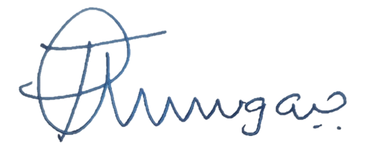

_______________________
Director Safety Regulation

